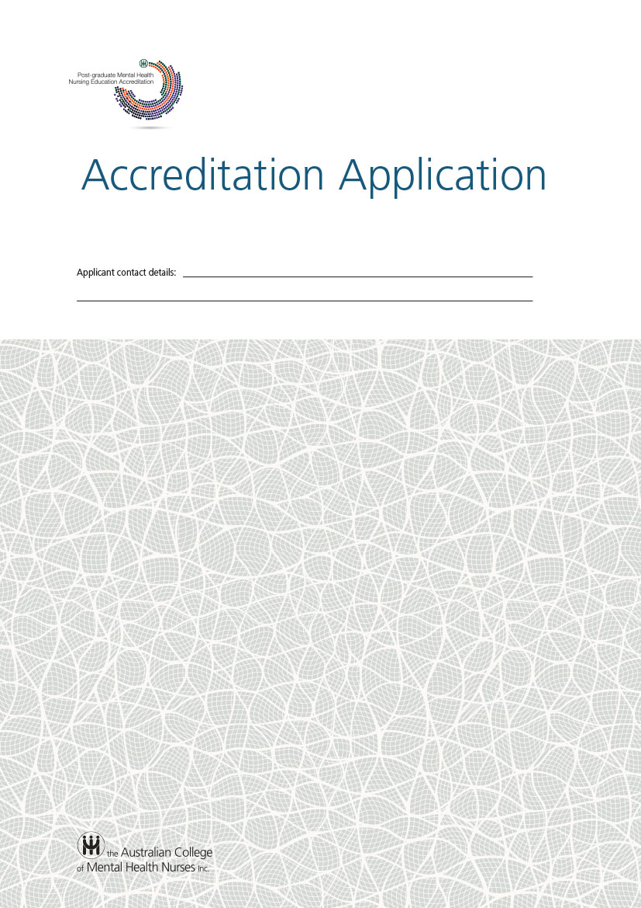

The ACMHN Accreditation Application

The Accreditation Application Pro forma should be read and used in conjunction with the ACMHN Guidelines for the Assessment and Accreditation of Post-graduate Mental Health Nursing Programs.

Version | Date
1.0 | December 2014
2.0 | June 2015
3.0 | March 2016

Acknowledgements
The generosity, advice and assistance provided by a range of health education program accreditation bodies and associations are acknowledged, in particular, the Council of Ambulance Authorities (CAA), which has generously permitted use of their document templates for accreditation processes.
A pilot of the implementation of the National Framework and application guidelines was undertaken and the processes evaluated and refined during 2015 as an ongoing process of continuing quality development. Further refinements will be undertaken.

Table of Contents

Preliminary Approval Application - Introduction 4
Part A: Application Cover Sheet 5
Part B: Background 6
Part C: The Standards 7
Standard 3.1: The Context of Post-graduate Mental Health Nursing Programs 7
Standard 3.2: The Outcomes of Programs 13
Standard 3.3: The Curriculum 15
Standard 3.4: Curriculum implementation 18

Introduction

This Application Form should be submitted when an educational institution intends to offer Post-graduate Mental Health Nursing programs for the first time or when making a major change to an existing program.

Part A of this pro forma must be completed and must be the first page of any application.

Part B of the pro forma provides the opportunity to give a descriptive history, development and future plans for the program.

Part C of the pro forma deals with the information relating to the standards that must be provided in order to support an application.

Part C also requires that applicants self-assess their compliance with each of the Accreditation Standards. If the application is in respect of a change to a currently accredited course, responses should be concise but also address explicitly any matters drawn to the applicant’s attention previously by the ACMHN.

The new or changed course must be able to satisfactorily demonstrate compliance to all required standards.

Accreditation procedures for new or changed programs
Please refer to the Guidelines for Assessment and Accreditation of Post-graduate Mental Health Nursing Programs when completing this application.

Part A: Application Cover Sheet

 | University
 | Address
Title of course
Head of School | Name
 | Title
 | Telephone
 | Email
Other contact (optional) |  | Name
Title
Telephone
Email
Address (if different to above)
Type of accreditation sought
Current accreditation status
Date of application
Date of commencement of course(s)

Part B: Background
Provide a background or history on the development of the Post-graduate Mental Health Nursing program giving an overall understanding of how the course has progressed and future plans. Enrolment data for the current cohort should be included in the application, if available.

Part C: The Standards

Standard 3.1: The Context of Post-graduate Mental Health Nursing Programs
3.1.1 Governance
Required:
The governance structures and functions of the academic organisational unit delivering the educational institution’s Post-graduate Mental Health Nursing education programs are required to be defined including the relationship within the educational institution.
Expected:
The governance structures are expected to set out the committee structure that will ensure that the outcomes of the program are met. This structure is expected to reflect representation from academic staff, students, consumers and carers and health services and professional stakeholders in decision- making.
Self-assessment – please indicate standard achieved for these criteria:
Required 
Expected 
Please supply evidence in support of your assessed level:
3.1.2 Academic leadership
Required:
- The responsibilities of the leadership of the academic organisational unit delivering the educational institution’s Post-graduate Mental Health Nursing education program must be clearly stated.
- The academic leadership is required to be evaluated at defined intervals with respect to the Post-graduate Mental Health Nursing education program’s goals, objectives and outcomes.
Self-assessment – please indicate standard achieved for these criteria:
Required i)  ii) 
Please supply evidence in support of your assessed level:
3.1.3 Educational budget and resource allocation
Required:
All programs are required to be consistent with the TEQSA guidelines for resourcing.
Expected:
The academic organisational unit responsible for the Post-graduate Mental Health Nursing education program is expected to have a clear line of responsibility and authority for the curriculum and its resourcing.
Self-assessment – please indicate standard achieved for these criteria:
Required 
Expected 
Please supply evidence in support of your assessed level:
3.1.4 Collaboration with the sector
Required:
The educational institution is required to have relationships with the sector that are based on a spirit of cooperation and shared commitment to achieving high quality education and research programs.
Expected:
These relationships should be expressed through a framework document(s) based on an agreed set of principles and which set out the understandings between the parties on arrangements for Post-graduate Mental Health Nursing education and research programs.
Self-assessment – please indicate standard achieved for these criteria:
Required 
Expected 
Please supply evidence in support of your assessed level:

3.1.5 Collaboration with the profession
Required:
The educational institution is required to demonstrate a collaborative relationship with the profession.
Expected:
- Academic staff engaged in Post-graduate Mental Health and Mental Health Nursing education programs should be encouraged to take up membership of professional associations eg the Australian College of Mental Health Nurses (ACMHN).
- There is an expectation for formal engagement between universities/providers and ACMHN through representation on appropriate committees and in program development.
Self-assessment – please indicate standard achieved for these criteria:
Required 
Expected i)  ii) 
Please supply evidence in support of your assessed level:

3.1.6 Interaction with other sectors
Required:
The educational institution is required to have a constructive interaction and formal relationships with the health and health-related sectors.

Expected:
The educational institution is expected to work with its partners to ensure all their academic staff are integrated and recognize their teaching obligations and responsibilities.
Self-assessment – please indicate standard achieved for these criteria:
Required 
Expected 
Please supply evidence in support of your assessed level:
3.1.7 Teaching-research nexus
Expected:
- The educational institution is expected to foster the relationship between research and teaching in Post-graduate Mental Health Nursing education programs.
- The interaction between research and teaching should be reflected in the Post-graduate Mental Health Nursing education program / curriculum.
Self-assessment – please indicate standard achieved for these criteria:
Expected i)  ii) 
Please supply evidence in support of your assessed level:
3.1.8 Inter-professional research
Expected:
- The educational institution is expected to demonstrate commitment to a multi-professional approach to the conduct of health research, scholarship and graduate research programs in the context of mental health care.
- Graduate research degree programs at Masters level are expected to be developed in collaboration with other health disciplines.
Self-assessment – please indicate standard achieved for these criteria:
Expected i)  ii) 
Please supply evidence in support of your assessed level:

3.1.9 Staff resources
Required:
- The academic organisational unit responsible for the Post-graduate Mental Health Nursing education program is required to have an appropriate profile of academic and administrative staff to support the Post-graduate Mental Health Nursing education program and other activities and to ensure sound management and deployment of its resources.
- Academics and clinical mentors are required to have expertise in mental health and mental health nursing
- The educational institution is required to define the responsibilities of personnel who contribute to the delivery of Post-graduate Mental Health Nursing education programs.
Expected:
- The management is expected to include a program of quality assurance and regular review.
- Casual and adjunct academic staff involved in the program should have the opportunity to provide feedback on the education program and to participate in appropriate teaching training and performance review and development.
Self-assessment – please indicate standard achieved for these criteria:
Required i)  ii)  iii) 
Expected i)  ii) 
Please supply evidence in support of your assessed level:

3.1.10 Staff appointment, promotion and development
Expected:
The educational institution is expected to have appointment, qualifications, promotion and development policies for academic and general staff.
Self-assessment – please indicate standard achieved for this criterion:
Expected 
Please supply evidence in support of your assessed level:

3.1.11 Staff indemnification
Required:
The educational institution is required to have arrangements for indemnification of teaching staff in relation to their involvement in clinical research and the delivery of Post-graduate Mental Health Nursing education programs.

Self-assessment – please indicate standard achieved for this criterion:
Required 
Please supply evidence in support of your assessed level:

Overall self-assessment – please evaluate how well the program meets Standard 3.1

Standard 3.2: The Outcomes of Programs
3.2.1 Goals and objectives
Required:
- The educational institution is required to define the Post-graduate Mental Health Nursing education program’s goals and objectives and make them known to students, health service partners and stakeholders.
- The program documentation is required to incorporate an educational process that will result in a mental health nurse prepared appropriately to the level of qualification attained and specified level of competence required.
- The program documentation is required to describe the abilities that students on the mental health nursing pathway will demonstrate on graduation relating to knowledge and understanding, skills, and attitudes affecting professional behaviour.
Self-assessment – please indicate standard achieved for these criteria:
Required i)  ii)  iii) 

Please supply evidence in support of your assessed level:

3.2.2 Program Outcomes
Required:
The program is required to articulate the abilities of the graduate expected on completion of the program and in a manner consistent with the National Framework for Postgraduate Mental Health Nursing Education.
Expected:
- The learning activities, core content and concepts should be designed and delivered in a manner which allows students to develop and demonstrate the abilities required for practice at the level of the relevant qualification.
- The educational program should demonstrate responsiveness to changes in the Australian education context, specifically addressing the curriculum issues identified as of contemporary importance.
Self-assessment – please indicate standard achieved for these criteria:
Required 
Expected i)  ii) 

Please supply evidence in support of your assessed level:
3.2.3 Work readiness
Required:
The educational institution is required to demonstrate it has developed an education program that provides students with the educational base for a graduate appropriate to the level of qualification to be attained and at the specified level of competence to meet the requirements for employment as a mental health nurse.
Self-assessment – please indicate standard achieved for this criterion:
Required 

Please supply evidence in support of your assessed level:

Overall self-assessment – please evaluate how well the program meets Standard 3.2

Standard 3.3: The Curriculum
3.3.1 Curriculum framework
Required:
The educational institution is required to have a curriculum framework that reflects the practice of the profession is consistent with the National Framework for Postgraduate Mental Health Nursing Education and includes learning methods that are consistent with the educational objectives of the program.

Expected:
The teaching and learning methods should acknowledge the students’ prior experiences and reflect their status as post-graduate students and qualified clinicians.
Self-assessment – please indicate standard achieved for these criteria:
Required 
Expected 

Please supply evidence in support of your assessed level:

3.3.2 Curriculum structure
Required:
- The educational institution is required to develop course/subject descriptions consistent with AQF Levels 8 and 9 outcomes within relevant articulated pathways.
- Descriptions must include the content, extent and sequencing of the curriculum that guides both staff and students on the level of knowledge and understanding, skills and attitudes expected of students at each stage of the program where relevant.

Self-assessment – please indicate standard achieved for these criteria:
Required i)  ii) 

Please supply evidence in support of your assessed level:
3.3.3 The continuum of learning
Required:
The educational institution is required to clearly articulate to students:
- the range of postgraduate education pathways available into the mental health nursing specialist field
- the pathways available for progression from other health professional programs; and
- other academic linkages available.
Expected:
The educational institution should develop and demonstrate processes to enable students to transfer to other university education programs and environments.
Self-assessment – please indicate standard achieved for these criteria:
Required i)  ii)  iii) 
Expected 

Please supply evidence in support of your assessed level:
3.3.4 Assessment of student learning
Required:
The educational institution is required to define and document the methods used for assessment including the criteria for progression in the course.
Expected:
Approaches to assessment are expected to be consistent with the National Framework.
Self-assessment – please indicate standard achieved for these criteria:
Required 
Expected 

Please supply evidence in support of your assessed level:

3.3.5 Monitoring and evaluation
Required:
- The educational institution is required to have a mechanism for program evaluation as part of its quality assurance process that monitors the curriculum, the quality of teaching and student progress and ensures that concerns are identified and addressed.
- Teacher, student and consumer feedback is required to be systematically sought, analysed and responded to appropriately.
- The educational institution is required to demonstrate formal procedures for regular review and updating of its program structure and functions and to rectify deficiencies and meet changing needs in a timely manner.
Expected:
- Program evaluation is expected to address the context of the educational process, the specific components of the program and the general outcomes.
- Measures of and information about attributes of graduates is expected to be used as feedback to program development.
- Teachers, students and consumers are expected to be actively involved in program evaluation planning and in using results for quality improvement.
- Student performance is expected to be analysed in relation to the program and its educational objectives.
- Student performance should be analysed in relation to student background, conditions and entrance qualifications, and should be used to provide feedback to student selection, program planning and student support.
- A wider range of stakeholders should have access to results of program evaluation and their views on the development and relevance of the education program should be considered.
- Feedback should be obtained from the authorities/organisations where students work after graduation and from graduates.

Self-assessment – please indicate standard achieved for these criteria:
Required i)  ii)  iii) 
Expected i)  ii)  iii)  iv)  v)  vi)  vii) 
Please supply evidence in support of your assessed level:

Overall self-assessment – please evaluate how well the program meets Standard 3.3

Standard 3.4: Curriculum implementation

3.4.1 Admission policy & selection
Required:
The educational institution is required to have an admission policy including a clear statement on the process for selection of students into programs.
Expected:
The relationship between selection, the educational program and the desired attributes of graduates should be stated. Any framework document between the educational institution and employer organisation should include agreed student selection criteria. Educational institutions should be cognisant of the employment requirements of employer organisations.

Self-assessment – please indicate standard achieved for these criteria:
Required 
Expected 

Please supply evidence in support of your assessed level:

3.4.2 Pathways, entry points and credits
Required:
The educational institution is required to ensure that programs provide defined credit transfer or articulation pathways.

Self-assessment – please indicate standard achieved for this criterion:
Required 

Please supply evidence in support of your assessed level:

3.4.3 Student intake
Expected:
The size of student intake, including international and domestic fee-paying students, is expected to be consistent with TEQSA Guidelines
Self-assessment – please indicate standard achieved for this criterion:
Expected 

Please supply evidence in support of your assessed level:

3.4.4 Student support and counseling
Expected:
- The educational institution is expected to offer appropriate student support including counselling, health and academic advisory services.
- Counselling is expected to be provided based on monitoring of student progress and should address students’ personal and social needs.
Self-assessment – please indicate standard achieved for this criteria:
Expected i)  ii) 

Please supply evidence in support of your assessed level:

3.4.5 Student representation
Expected:
The educational institution is expected to have a policy on student representation and appropriate participation in the design, management and evaluation of programs and in other matters relevant to students.

Self-assessment – please indicate standard achieved for this criterion:
Expected 

Please supply evidence in support of your assessed level:

3.4.6 Student indemnification
Required:
The educational institution is required to have policies regarding adequate indemnity for the relevant activities of students.
Self-assessment – please indicate standard achieved for this criterion:
Required 
Please supply evidence in support of your assessed level:

3.4.7 Educational resources
Required:
- The educational institution is required to have sufficient facilities for the staff and student population to ensure programs can be delivered adequately.
- The educational institution, in collaboration with industry employer organisations, is required to ensure appropriate facilities for communication and information exchange between sites.

Expected:
Library facilities available to staff and students should include access to electronic databases, supportive staff and a reference collection adequate to meet curriculum and research needs.

Self-assessment – please indicate standard achieved for these criteria:
Required i)  ii) 
Expected 

Please supply evidence in support of your assessed level:

3.4.8 Educational exchanges
Expected:
The educational institution is expected to have a policy for collaboration with other educational institutions and for the transfer of educational credit.
Self-assessment – please indicate standard achieved for this criterion:
Expected 

Please supply evidence in support of your assessed level:

3.4.9 Clinical training resources
Required:
- The educational institution is required to ensure there is adequate professional experience and the necessary resources to support the student.
- Professional experience is required to be governed by formal learning agreements between the educational institution and the appropriate health service/organisation / hospital / primary health care setting.

Self-assessment – please indicate standard achieved for these criteria:
Required i)  ii) 

Please supply evidence in support of your assessed level:

Overall self-assessment – please evaluate how well the program meets Standard 3.4

A major change in a paramedic program could be a - Change to the educational institution setting - Significant change in objectives, or a substantial change in philosophy or emphasis - Change in the length of the course, especially any reduction in length - Major change in the format or overall sequence of subjects of the course - Major change in teaching, especially those involving changes to contact hours, or a major change to assessment methods. - Significant changes forced by a major reduction in resources leading to an inability to achieve the objectives of the existing course

